Curriculum Vitae
- Personal Information
(i) | Name | Ms. Anushree Acharya | Photo  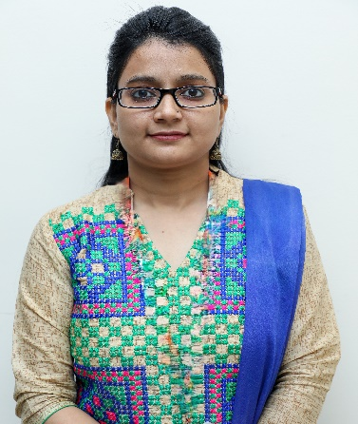
(ii) | Qualification | MBA (Hospital Administration)
(iii) | Designation | Assistant Professor
(iv) | Email-id | anushreeacharya07@gmail.com
(v) | Employee No. | 8305253
(Vi) | Department | Department of Management Studies
(vii) | Experience | 8 years

- Educational Qualification
S. No. | Degree | Specialization | Year | University/Board
1. | MBA | Hospital Administration | 2016 | Devi Ahilya Vishwavidyalaya, Indore
2. | BBA | Hospital Administration | 2014 | Devi Ahilya Vishwavidyalaya, Indore
Certifications
1

- Research Interests
- Healthcare Accreditations
- Sustainability in Healthcare,
- Public Health

- Research Paper Publications
(I) International/National Journal Publications
- Sustainability in Healthcare: A New Dimension in the Healthcare Sector in India, published in Bulletin of Environment Pharmacology and Life sciences journal (Web of Sciences)
- Strengths and Shortcomings of Artificial Intelligence & E-health to secure Health in Global Era published in Bulletin of Environment Pharmacology and Life sciences journal (Web of Sciences)
- Role of Emotional Intelligence: A New Force Strengthening the Future Healthcare Sector in India published in Bulletin of Environment Pharmacology and Life sciences journal (Web of Sciences)

- List of Conferences/Workshops/Seminars Attended
- International Conference on Gandhi Concept of Education and National Education Policy (NEP 2020): Idea, Opportunity, and Implementation”
- National Webinar organized by Gandhigram Rural Institute, Ministry of Education, Government of India on the topic of “Academic Writing and Research Publication in Indexed Journals.
- National Intellectual Property Awareness Mission, organized by Office of the Controller General of Patents, Designs and Trade Marks, Ministry of Commerce and Industry, Government of India.
- Seminar on Quality and Ethics in Research

- FDP/MDP
- Attended FDP on ‘Fostering Research Integrity in Various Fields’, SRM Institute of Science and Technology, Department of Visual Communication
- Attended FDP on ‘Research paper Writing for Scopus/WOS/ABDC Indexed Journals. Faculty of Commerce and Management, SGT University
- Attended FDP on Entrepreneurship, Innovation and Digital skills in the new era of AI, Moradabad Institute of Technology and AICTE
- Attended FDP on ‘Overview of Capital Market’, Bombay Stock Exchange Broker’s Forum in association with Seth Hirachand Mutha College of Arts, Commerce and Science Kalyan (W).
- Attended FDP on Role of Technology and some specific tools in research organized by Prodigy-A Science, FOSc, Academic Association, SGT University.
- Attended FDP on Artificial Intelligence - Impacts on Telemedicine, Gokaraju Rangaraju Institute of Engineering and Technology, AICTE, ATAL Academy
- Attended FDP on Stress Management- AICTE, ATAL Academy, Government College of Engineering, Tirunelveli, AICTE, ATAL Academy,
- Attended FDP on Productivity Enhancement through Empowered Youth, GRG Polytechnic college, AICTE, ATAL Academy

