Ms. -SHIVANI SHUKLA-----
- Personal Information
(i) | Name | Shivani Shukla | 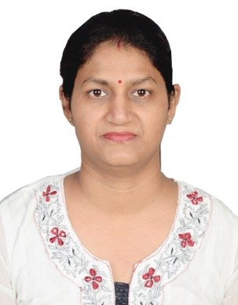
(ii) | Qualification | M.E.
(iii) | Designation | Asst. Professor
(iv) | Email-id | gs3305120@sgsitsindore.in
(v) | Employee No. | 3305120
(Vi) | Department | Electronics and Instrumentation Engineering
(vii) | Experience | 10years

- Educational Qualification
S. No. | Degree | Specialization | Year | University/Board
1. | M.E. | Electronics and Communication Engineering | 2010 | RGPV, Bhopal
2. | B.E. | Electronics and Communication Engineering | 2004 | RGPV, Bhopal

- Research Interests
Sigma Delta ADC

- Research Paper Publications
(I) International/National Journal Publications
Nil
(II) International/National Conference Publications
- Shivani Shukla “Performance Evaluation of Sigma Delta ADC using SFDR”, in proc. of International Conference of Indo Global Chambers of Commerce Industries and Agriculture, Nov 2013.
- Shivani Shukla “The performance of Sigma Delta ADC with Quantization Noise for SDR 3G Mobile Receiver” in International Conference on Emerging Trends in Mathematics and Computer Applications (ICETMCA), Dec 2010.
- Shivani Shukla “Feature Extraction of ECG Signal using HHT Algorithm” in International Research Conference on Innovative Strategies in Commerce, Management, Engineering, Technology and Social Sciences(IJMR Multidisciplinary Research).
- Shivani Shukla “The simulating result for parameter Spurious Free Dynamic Range for Sigma Delta ADC 3G Mobile Receiver”, in National Conference on Recent Advances in Embedded System & VLSI design organized by SIMS, Sep 2012.
- Shivani Shukla “Performance of Sigma Delta ADC with Spurious Free Dynamic Range for 3G Mobile Receiver” in National Conference on Advancements & future Trends in VLSI Design & Embedded System (ATVES 2010).

- List of Conferences/Workshops/Seminars Organized
- Organizing Secretary, National conference RAEVD-2012, Indore, Sep 2011.
- Organizer of the workshop “Embedded Systems and Robotics” Indore, June 2012.

- Invited Lectures/Expert Talks/Chairmanships at Conferences
Nil

