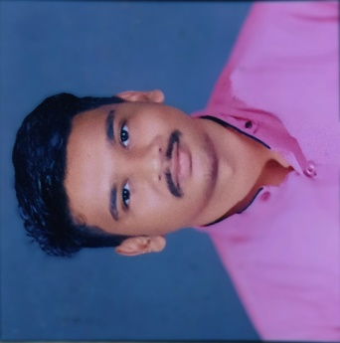
Template for Faculty Data
Faculty Name: Mr. RAHUL SUMAN
Designation: Assistant Professor
Employee ID: employee ID of the faculty
Qualification: M.E. (Design and Thermal)
Phone No.: college extension no. can be given (plz don’t provide mobile no.)
Email Id: rahulsuman1122@gmail.com

- About Faculty
Rahul Suman is currently working as an Assistant Professor in Mechanical Engineering Department. He has working experience of more than 7 years in technical education. His area of interest is Analysis of various Expansion chamber, Design and Thermal, various FEA and design software’s, etc.
Educational Qualification (As given in bio data uploaded on website)
S. No. | Degree | Specialization | Year | University/Board
1. | M.E. | Design & Thermal Engineering | 2015 | DAVV, INDORE
 | B.E. | Mechanical Engineering | 2013 | RGPV, Bhopal
 | HSC | Science Mathematics | 2009 | ISC Board
4. | High School | All Subjects | 2007 | ICSC Board

- Work Experience
S. No. | Designation | Department | Employer Name | Duration of Employment
 | Assistant Professor | Mechanical Engineering | SGSITS, Indore | 01/08/2023 to Till date
 | Assistant Professor | Mechanical Engineering | I.E.T-DAVV, INDORE | 01/08/2018 to 30/07/2023
 | Assistant Professor | Mechanical Engineering | PIEMR, INDORE | 03/082015 to 16/07/2017

- Research Detail

Details can be entered in tabular form or in list form.

- PhD Supervision

Details of PhD supervision is to be added.

- Publication

- Gupta A.K. and Suman Rahul, “An Approach for Transmission Loss Validation and Measurement of Various Reactive Mufflers with FEA Acoustic Module”, International Journal for Research in Applied Science & Engineering
Technology (IJRASET) , Volume 3 Issue VI, June 2015, ISSN: 2321-9653

- Gupta A.K. and Suman Rahul, “Effect of Changing Aspect Ratio, Expansion Ratio and Ovality Parameter on Expansion Chamber for the Performance of Transmission Loss “, International Journal Of Research Science & Management ISSN: 2349-5197, July 07 2015.

- Project

Details regarding Projects completed and ongoing can be entered in the tabular form or in the list form.

- Testing & Consultancy

Details regarding Testing & Consultancy can be entered in the tabular form or in the list form. If the information is large than important points may be included and rest can be added in detailed profile or link can also be provided.

- Other Details

- Organizing committee member in organizing the event BAJA SAE 2010 when Acropolis Institute of Technology and Research, Indore was the organizer and the Host of event SAE BAJA -2010 from 29th -31st January 2010.
- Done DRIVER’s training of FORMULA car held at Kari Motor Speedway, Coimbatore from 16th- 20th August 2012 for SUPRA SAEINDIA -2012 held at Budh International Circuit-2012.

